# [LAW & ORDER: SPECIAL VICTIMS UNIT: Warren Leight Reflects on the Unexpected Lewis Arc](http://www.givememyremote.com/remote/2019/09/20/law-order-special-victims-unit-warren-leight-reflects-on-the-unexpected-lewis-arc/?s=09)

September 20, 2019 by [Marisa Roffman](https://www.givememyremote.com/remote/author/marisa/)

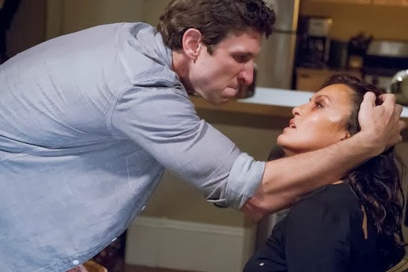

***LAW & ORDER: SPECIAL VICTIMS UNIT — “Surrender Benson” Episode 1501 — Pictured: (l-r) Pablo Schreiber as Lewis, Mariska Hargitay as Detective Olivia Benson — (Photo by: Michael Parmelee/NBC/NBCU Photo Bank via Getty Images)***

Over the past 20 seasons of LAW & ORDER: SPECIAL VICTIMS UNIT’s Olivia Benson (Mariska Hargitay) has gone through more traumatic situations (and, to be fair, a few good ones!) than most humans. But after all of these years, her prolonged entanglement with Willam Lewis ([Pablo Schreiber](http://www.givememyremote.com/remote/2019/04/17/halo-pablo-schreiber-master-chief/)) remains one of the most twisted.

Lewis first crossed paths with the then-detective through a seemingly routine investigation. But his manipulative ways soon became apparent, and things escalated when Lewis kidnapped and tortured/assaulted Benson. But that ended up being just the beginning of his impact on her life.

“We didn’t know [what it would evolve into],” showrunner Warren Leight acknowledges. “I knew we wanted to do an episode where she was was in disturbing jeopardy. I thought that Olivia is such a powerful person character, and she’s such a badass—what’s it like for her to experience a lack of power? That’d be interesting to write.”

The issue then became who they could cast opposite Hargitay in the role. “I didn’t know who could play [that]; it’s tough to find somebody who can counter that you believe,” Leight explains. He ran into Pablo Schreiber, who had worked on Leight’s previous series LIGHTS OUT, at a basketball game and the pieces clicked into place.

“What I love about Pablo is there’s nothing you can write for him where he’s like, ‘That’s too f—ed up,’” Leight says. “Like, it just doesn’t occur to him. And in fact, he brought a lot to it. We knew the season was going to end with him pulling the gun, but we hadn’t actually been picked up at that point. So that could have been the [accidental] series end.”

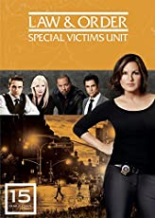

[**Law & Order: Special Victims Unit - The Fifteenth Year**](https://aax-us-east.amazon-adsystem.com/x/c/QlzTKoVFfKl1LV8CfGrRZAEAAAF00jYMWwEAAAFKAWgnIbc/https://www.amazon.com/dp/B00GTZWXFU/ref=sm_n_ma_dka_BR_pr_ran?adId=B00GTZWXFU&creativeASIN=B00GTZWXFU&linkId=10b29ec7d2ef9c71a6ff0d25cdb924d8&tag=gimemyre0d-20&linkCode=w58&ref-refURL=http%3A%2F%2Fwww.givememyremote.com%2Fremote%2F2019%2F09%2F20%2Flaw-order-special-victims-unit-warren-leight-reflects-on-the-unexpected-lewis-arc%2F&slotNum=0&imprToken=NL9Idtlcmwk25Q7kcLl0ew&adType=smart&adMode=manual&adFormat=card&impressionTimestamp=1601254592978)

By **Mariska Hargitay, Danny Pino, Kelli Giddish, Ice-T (DVD)**

**$22.22**~~$44.98~~

Rated 4.7 out of 5 by 472 reviewers on Amazon.com

[Buy Now](https://aax-us-east.amazon-adsystem.com/x/c/QlzTKoVFfKl1LV8CfGrRZAEAAAF00jYMWwEAAAFKAWgnIbc/https://www.amazon.com/dp/B00GTZWXFU/ref=sm_n_ma_dka_BR_pr_ran?adId=B00GTZWXFU&creativeASIN=B00GTZWXFU&linkId=10b29ec7d2ef9c71a6ff0d25cdb924d8&tag=gimemyre0d-20&linkCode=w58&ref-refURL=http%3A%2F%2Fwww.givememyremote.com%2Fremote%2F2019%2F09%2F20%2Flaw-order-special-victims-unit-warren-leight-reflects-on-the-unexpected-lewis-arc%2F&slotNum=0&imprToken=NL9Idtlcmwk25Q7kcLl0ew&adType=smart&adMode=manual&adFormat=card&impressionTimestamp=1601254592978)

After Lewis survived Benson attacking him and escaping her kidnapping, the series brought him back a handful more times. “It was it was one of those things where the more we wrote for him, the more interesting it got,” Leight says. “The last time I called him, I said, ‘I can bring you back [and] we can do all these things.’ And he said, ‘I’ll come back. But last time, and I have to die. And I want to choose the way I die.’”

“I said, ‘Sure, okay,’” he continues with a laugh. “But that forced me to come up with a really f—ed up way for him to die, which was to blow his brains out on to her. And I just thought, ‘Okay, he’s gonna like this.’ His character had control until the end. So that was great fun. I like working with actors and collaborating with them.”

Traumatizing, on a different level, was season 14’s “Born Psychopath,” about a young child, Henry (Ethan Cutkosky), whose psychopathic tendencies put his entire family at risk.

“[Ethan] was great,” Leight, who co-wrote the hour with Julie Martin, recalls. And writing for children is a bit different than the work they do for adults. “You want to you want them to be realistic. You don’t want it to be too cute. You don’t want them to be you want to write with some awareness of their [headspace]: are they extraordinarily intelligent for their age, are they developmentally stunted for their age? Or is it both? Where are they different? Just the way talking to a kid is different than talking to a grown up, writing for a kid is different…and you have to you know, meet them on their level if you can. I like it, but it’s stressful.”

However, that particular story might not be entirely done: “I’m thinking [that character] should be out of the system by now. But we haven’t discussed it [officially].”